
Proceedings of the 19th French Congress of Sedimentology, Lille, 2024. Article DOI: XXXXX

TITLE OF YOUR EXTENDED ABSTRACT
Author, A¹, Author, B², and Author, C³
¹Institution 1
²Institution 2
³Institution 3
E-mail (corresponding author)

Abstract: Objective, methods, and findings must be summarized here in a few sentences.
Keywords: Maximum 5 items allowed, separated by commas.

- Introduction
Authors are invited to submit an extended abstract not exceeding four (4) pages in English or French. Extended abstracts will be published by ASF with CrossRef DOIs and hosted in the HAL database. This is the template that must be followed.
- Materials and methods
The methodology must be clearly stated and described in sufficient detail or with sufficient references.
- Results and discussion
The findings and arguments of the work should be explicitly described and illustrated. All the tables, images and figures should be centered. The contents below showcases the template for specific materials. Sub-titles may be used for separate sub-sections.
  - Equations
Equations should be centered and numbered consecutively, as in Eq. [1].

[1]

  - List
Lists can be provided following this template:
- First item;
- Second item;
- As many items as requested following roman numbering with low cap letters. The final item followed by a final mark instead of a semicolon.

  - Tables and figures
Tables and figures should appear in one column of a page and be numbered consecutively. Tables should be designed to have a uniform style throughout the paper, following the style shown in Table 1.

 | A | B | C | D
A | Aa | Ab | Ac | Ad
B | Ba | Bb | Bc | Bd
C | Ca | Cb | Cc | Cd
D | Da | Db | Dc | Dd
E | Ea | Eb | Ec | Ed
Table 1. Caption heading for a table should be placed at the top of the table and within table width.

Figures and their captions may appear on the same page, and a centered caption should appear directly beneath the figure. It is preferable that figures be mounted in portrait style and figure captions are no longer than two lines. On figures showing graphs, both axes must be clearly labeled (including units if applicable).
Authors are advised to prepare their figures in either black and white or color. Please prepare the figures in high resolution (300 dpi) for half-tone illustrations or images. Pictures must be sharp enough otherwise they will be rejected. Figures must be originals, computer-generated or drafted, and placed within the text area where they are discussed. Figure 1 shows one example.
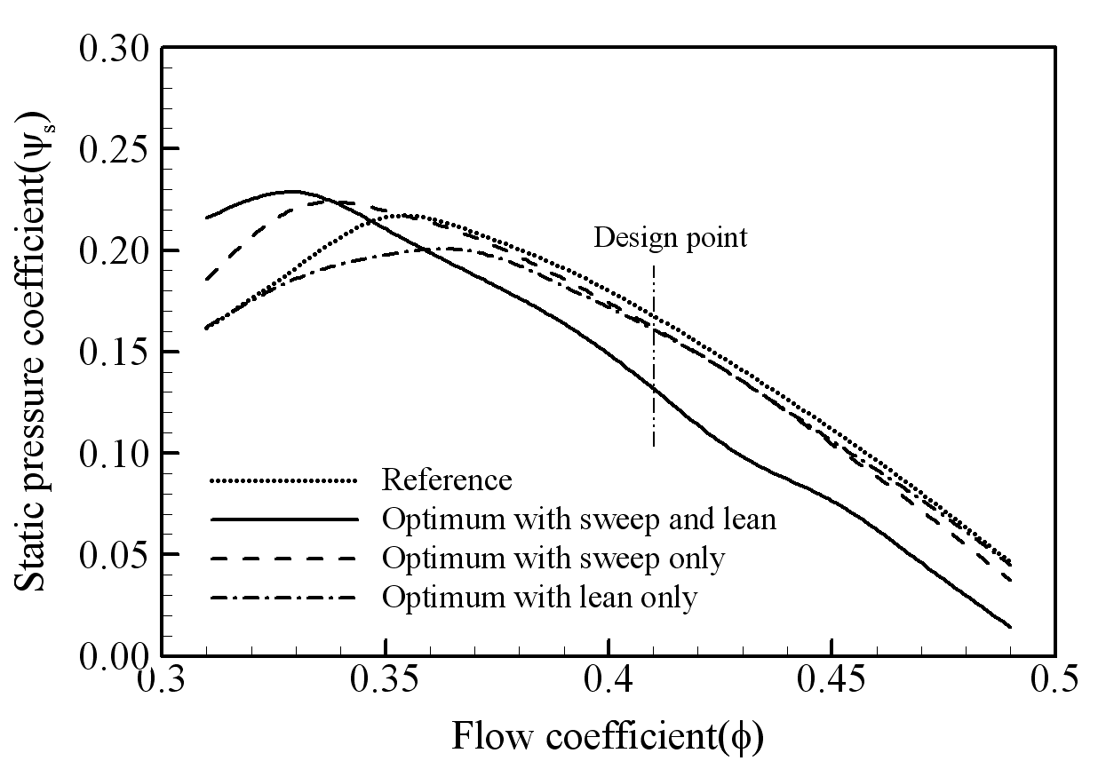
Figure 1. The caption heading for a figure should be placed below the figure and within figure/illustration width.
  - Footnotes
Footnotes are denoted by a character superscript in the text b.
  - Units
Use either SI (MKS) as primary units. English or CGS units may be used as secondary units (in parentheses). Avoid combining SI and CGS units. This often leads to confusion because equations do not balance dimensionally. If you must use mixed units, clearly state the units for each quantity that you use in an equation. Do not mix complete spellings and abbreviations of units. Spell out units when they appear in text.
- CONCLUSION
Conclusions should include (1) the principles and generalisations inferred from the results, (2) any exceptions to, or problems with these principles and generalisations, (3) theoretical and/or practical implications of the work, and (5) conclusions drawn and recommendations.

- ACKNOWLEDGMENT
The authors would like to express appreciation for the support of the sponsors [Project Number = XXXXXXX].

- REFERENCES
In the text, references should be cited with the name of the author(s) with the year of publication in brackets, e.g., nice literature (Caillaud et al., 2022; Metatla et al., 2024; Oguadinma et al., 2024; Ouchaou et al., 2024; Tessier et al., 2024).
In reference section, references should be listed arranged in alphabetical order beginning with the author’s names and initials, followed by the year of publication, title of periodical, volume and page.

Example:

Caillaud, A., Quijada, M., Hlohowskyj, S.R., Chappaz, A., Bout-Roumazeilles, V., Reynaud, J.-Y., Riboulleau, A., Baudin, F., Adatte, T., Ferry, J.-N., Tribovillard, N., 2022. Assessing controls on organic matter enrichments in hemipelagic marls of the Aptian-Lower Albian Blue Marls of the Vocontian Basin (France): an unexpected variability observed from multiple “organic-rich” levels. BSGF - Earth Sci. Bull. 193, 2.
Metatla, I., Reynaud, J.-Y., Ghienne, J.-F., Vinn, O., Harouz, C., El Albani, A., Mazurier, A., Mahboubi, S., 2024. Shell Beds in Ordovician storm- to tide-dominated deposits, Daoura (Ougarta range), Algeria. Bull. Geosci. 149–168.
Oguadinma, V.O., Reynaud, J.-Y., Delhaye-Prat, V., Akpi, T., Thackrey, S., Lanisa, A., Dall’Asta, M., 2024. Gravity tectonics controls on reservoir-scale sandbodies: Insights from 3D seismic geomorphology of the canyons buried in the upper slope of the Eastern Niger delta basin. Energy Geoscience 5, 100293.
Ouchaou, R., Reynaud, J., Besse, Y., Tilehghouatine, A., Armynot du Châtelet, E., Trentesaux, A., Abraham, R., Deschodt, L., Hulin, G., Desoutter, S., Fores, B., Simon, F., Lançon, M., 2024. The depositional record of the French Flemish Coastal plain since antiquity: Impacts of land reclamation in a tide‐dominated estuary. The Depositional Record dep2.279.
Tessier, B., Reynaud, J.-Y., Cuitiño, J.I., Scasso, R.A., Pancrazzi, L., Duperron, M., Weill, P., Bout-Roumazeilles, V., Du Châtelet, E.A., Kuinkel, A., Lortie, T., Dezileau, L., 2024. The hypertidal Santa Cruz–Chico River estuary (South Patagonia, Argentina): A hybrid ria-type system under extreme tides, arid climate and active uplift. Sedimentary Geology 471, 106728.

b Just like this one.(Caillaud et al., 2022)

